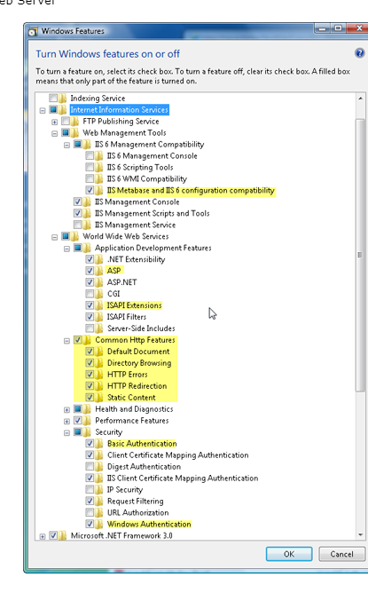

Code cơ bản ' <%

' Dim conn

' Set conn = Server.CreateObject("ADODB.Connection")

' Set rs =Server.CreateObject("ADODB.Recordset")

'     On Error Resume Next

' conn.Open "Provider=SQLOLEDB;Data Source=CUONG;Initial Catalog=master;User Id=sa;Password=123;"

' If Err.Number <> 0 Then

'     Response.Write "failure"

' Else

'     rs.Open "SELECT * FROM test", conn

'     If Not rs.EOF Then

'    Do While Not rs.EOF

'             Response.Write "<h1>" & rs("id") & "</h1>"

'             rs.MoveNext

'         Loop

'      Else

' Response.Write "No data found"

' End If

' End If

' conn.Close

' Set conn = Nothing

' Function myFunction(param1, param2)

'   ' code goes here

' End Function

' Sub Button_Click()

'   myFunction arg1, arg2

' End Sub

' %>

<!-- #include file="MyFunctions.asp" -->